Terraform Challenge -01

Write a code using Terraform that deploys and achieves the following:-
1.Create an EC2 Instance on AWS Cloud using the below-mentioned ubuntu AMI and instance_type. Or, (You can use of your choice as well) ami = "ami-0461b1436c9b3c1a3" instance_type = "t2.micro"
2. Install a web server on the same EC2 Instance. The web server should listen on port 8080.
3.Create a Docker-compose file for the project: https://github.com/betawins/cricbuzz-docker-hello-world.git and point it to port 8000.
4.Make the web server point to the above service so that 8080 returns the response from the Docker service.
- Configure to Save the Logs in the location /var/log/cb.log
- Write the Log rotate configuration for the above file

Task Title
Deploy a Dockized Application on AWS EC2 Using Terraform with Nginx Reverse Proxy and Log Rotation
Objective
To provision an EC2 instance on AWS using Terraform, deploy a Docker-based application, configure Nginx as a reverse proxy to route traffic from port 8080 to 8000, store logs in /var/log/cb.log, and configure log rotation for effective log management.

Prerequisites
- AWS account with required IAM permissions
- Terraform installed on local machine
- SSH public key available (~/.ssh/id_rsa.pub)
- Internet access to clone GitHub repository
- Basic knowledge of AWS, Terraform, Docker, and Nginx
Step-by-Step Implementation:
Step 1: Terraform Configuration Setup
Created a Terraform configuration file (main.tf) with:
- AWS provider configuration (region: us-east-1)
- Key pair creation using local SSH public key
- Custom security group allowing ports 22, 8080, and 8000
- EC2 instance resource using Ubuntu 22.04 AMI
Step 2: Terraform Initialization
Executed the following command to initialize Terraform and download required provider plugins:
terraform init
Terraform initialized successfully.
Step 3: Terraform Apply
Executed Terraform apply to provision infrastructure:
terraform apply
Confirmed the execution by entering yes.
Terraform successfully created:
- AWS Key Pair
- Security Group
- EC2 Instance
Step 4: EC2 Instance Verification
Verified in AWS Console that:
- EC2 instance is in Running state
- Public IPv4 address is assigned
- Instance status checks passed
Step 5: Automated Software Installation (User Data)
Using user_data, the following packages were installed automatically during instance launch:
- Docker
- Docker Compose
- Nginx
- Git
- Logrotate
The following services were enabled and started:
- Docker
- Nginx
Step 6: Docker Application Deployment
- Cloned the GitHub repository:
- https://github.com/betawins/cricbuzz-docker-hello-world.git
- Created a docker-compose.yml file
- Deployed a Docker container exposing the application on port 8000
The Docker application was verified using:
http://<EC2_PUBLIC_IP>:8000
Step 7: Nginx Reverse Proxy Configuration
- Removed default Nginx site configuration
- Created a custom Nginx configuration to:
  - Listen on port 8080
  - Forward requests to Docker service on port 8000
  - Write access and error logs to /var/log/cb.log
Nginx service was restarted to apply changes.
Step 8: Application Access Validation
- Verified application access through Nginx reverse proxy:
- http://<EC2_PUBLIC_IP>:8080
- Confirmed that traffic on port 8080 is correctly routed to the Docker application.
Step 9: Log File Verification
- Verified logs were created in:
- /var/log/cb.log
- Confirmed HTTP request entries were being recorded.
Step 10: Log Rotation Configuration
- Created logrotate configuration file:
- /etc/logrotate.d/cb-log
- Configured:
  - Daily log rotation
  - Retention of 7 log files
  - Compression of old logs
  - Safe reload of Nginx after rotation
Terraform Script:
provider "aws" {
region = "us-east-1"
}
# -------------------------
# Key Pair (uses your local public key)
# -------------------------
resource "aws_key_pair" "cb_key" {
key_name = "cb-key"
public_key = file("~/.ssh/id_rsa.pub")
}
# -------------------------
# Security Group (Allow SSH + 8080 + 8000)
# -------------------------
resource "aws_security_group" "cb_sg" {
name = "cb-sg"
description = "Allow SSH and app ports"
ingress {
description = "SSH"
from_port = 22
to_port = 22
protocol = "tcp"
cidr_blocks = ["0.0.0.0/0"]
}
ingress {
description = "Nginx Reverse Proxy Port"
from_port = 8080
to_port = 8080
protocol = "tcp"
cidr_blocks = ["0.0.0.0/0"]
}
ingress {
description = "Docker App Port"
from_port = 8000
to_port = 8000
protocol = "tcp"
cidr_blocks = ["0.0.0.0/0"]
}
egress {
description = "Allow all outbound"
from_port = 0
to_port = 0
protocol = "-1"
cidr_blocks = ["0.0.0.0/0"]
}
}
# -------------------------
# EC2 Instance
# -------------------------
resource "aws_instance" "cb_ec2" {
ami = "ami-0b6c6ebed2801a5cb" # Ubuntu Server 22.04 LTS (HVM), SSD Volume Type
instance_type = "t3.micro"
key_name = aws_key_pair.cb_key.key_name
vpc_security_group_ids = [aws_security_group.cb_sg.id]
user_data = <<-EOF
#!/bin/bash
set -e
apt-get update -y
# Install packages
apt-get install -y docker.io docker-compose nginx git logrotate
systemctl enable docker
systemctl start docker
systemctl enable nginx
systemctl start nginx
# Clone project
cd /opt
rm -rf cricbuzz-docker-hello-world || true
git clone https://github.com/betawins/cricbuzz-docker-hello-world.git
cd cricbuzz-docker-hello-world

# Create docker-compose file (App runs on 8000)
cat > docker-compose.yml <<EOL
version: "3.8"
services:
cb-app:
image: nginx:alpine
container_name: cb-app
ports:
- "8000:80"
restart: always
EOL
# Start docker container
docker-compose up -d
# Nginx reverse proxy config (8080 -> 8000)
rm -f /etc/nginx/sites-enabled/default
cat > /etc/nginx/sites-available/cb-proxy <<EOL
server {
listen 8080;
access_log /var/log/cb.log;
error_log /var/log/cb.log;
location / {
proxy_pass http://127.0.0.1:8000;
proxy_set_header Host \$host;
proxy_set_header X-Real-IP \$remote_addr;
proxy_set_header X-Forwarded-For \$proxy_add_x_forwarded_for;
}
}
EOL
ln -s /etc/nginx/sites-available/cb-proxy /etc/nginx/sites-enabled/cb-proxy
systemctl restart nginx
# Logrotate config for /var/log/cb.log
cat > /etc/logrotate.d/cb-log <<EOL
/var/log/cb.log {
daily
rotate 7
compress
missingok
notifempty
create 0644 root root
sharedscripts
postrotate
systemctl reload nginx > /dev/null 2>/dev/null || true
endscript
}
EOL
EOF
tags = {
Name = "cb-ec2"
}
}
output "ec2_public_ip" {
value = aws_instance.cb_ec2.public_ip
}
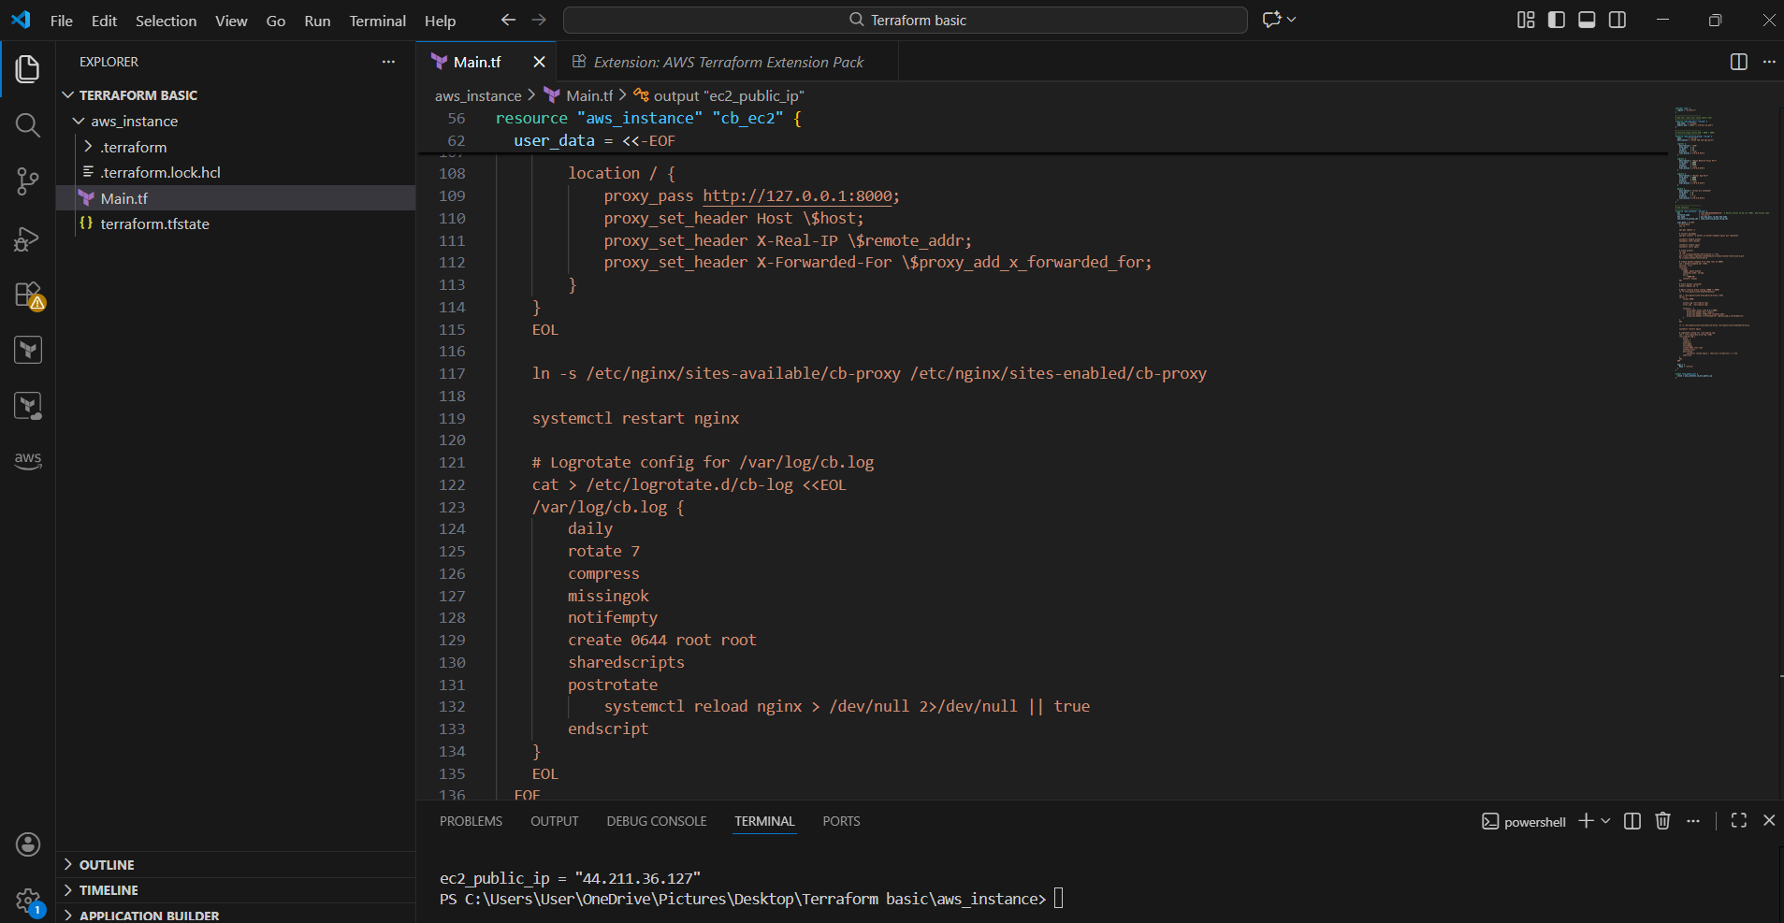
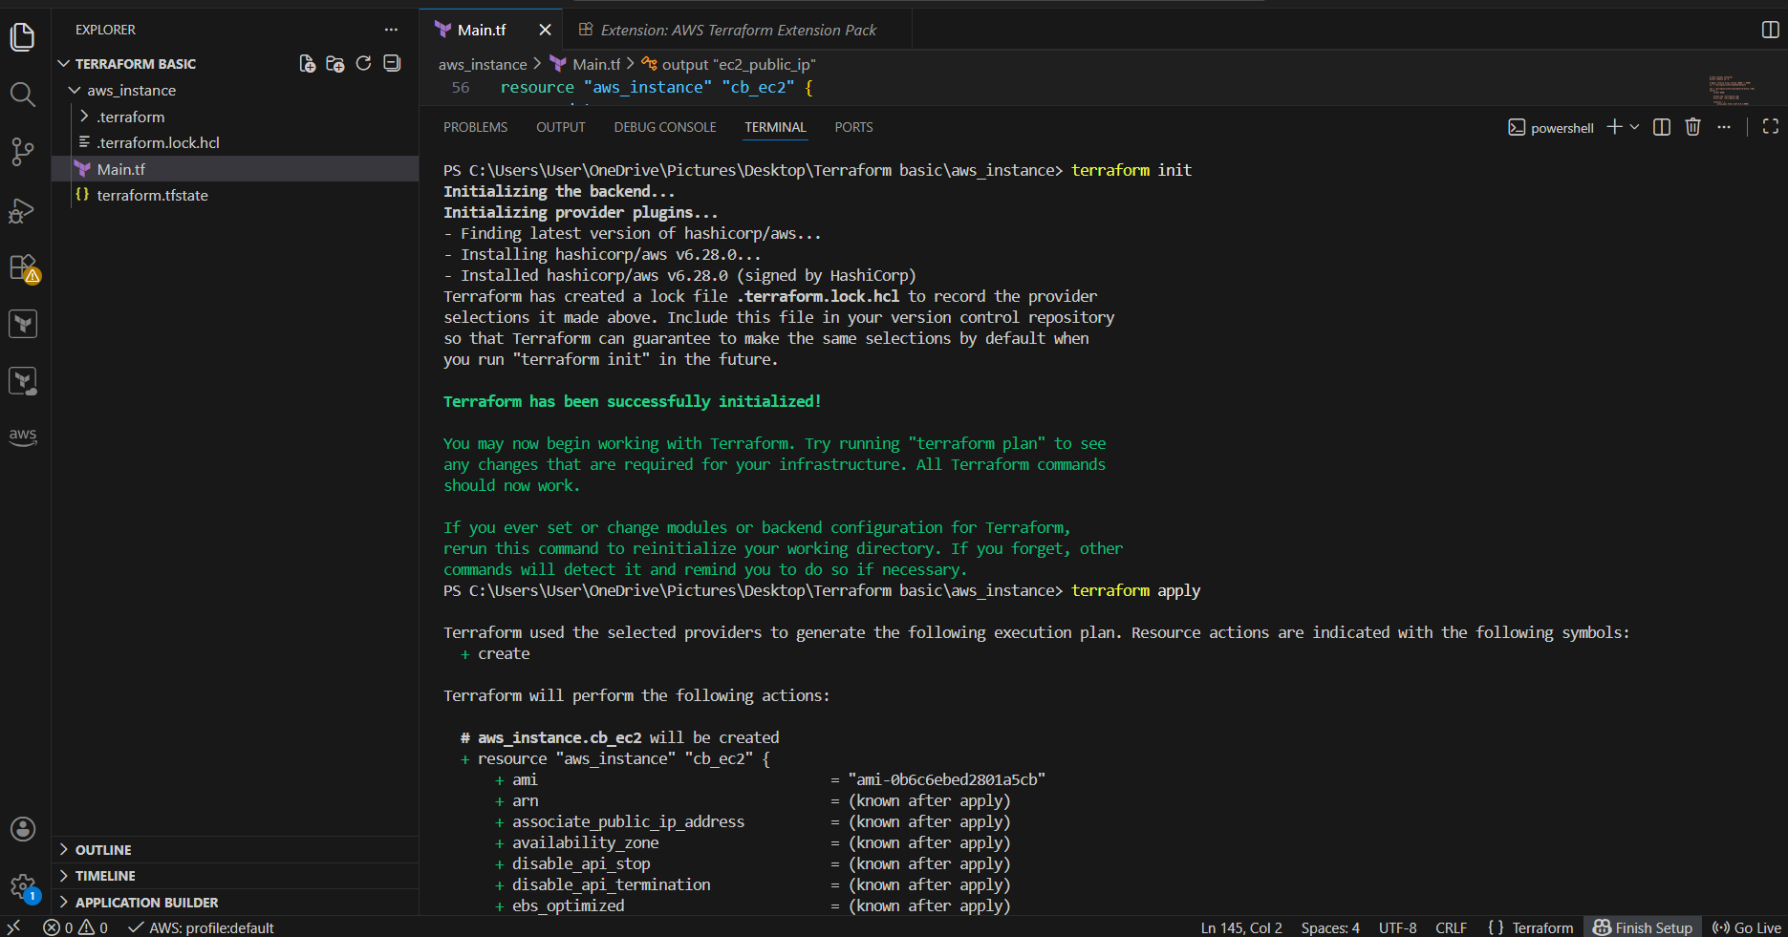
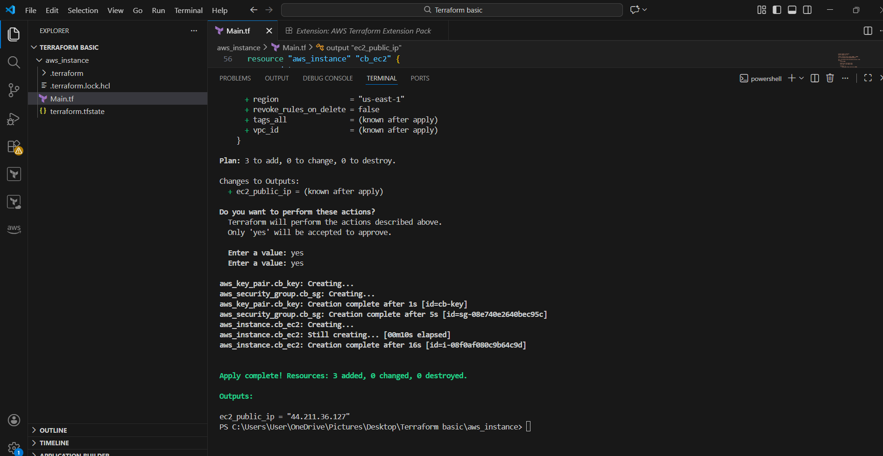
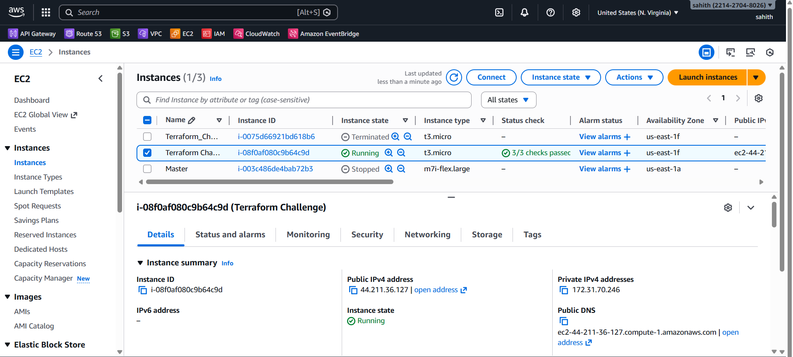
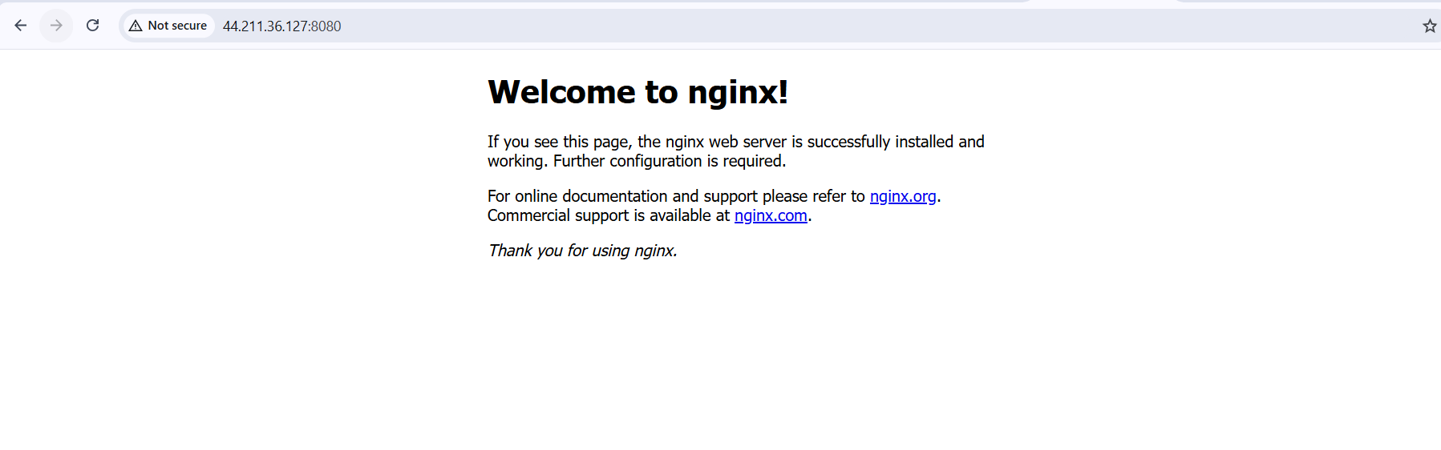
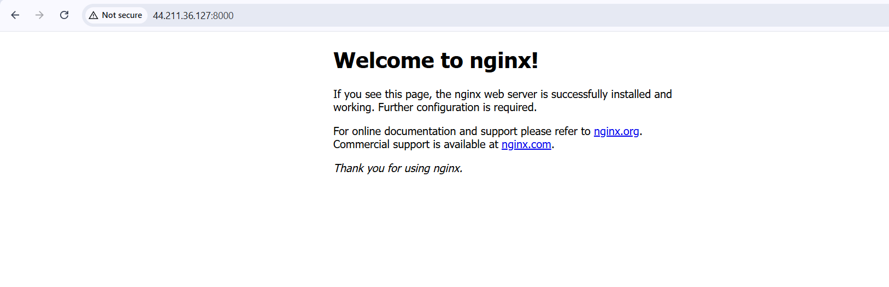
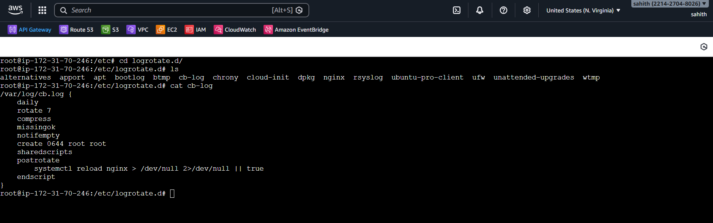
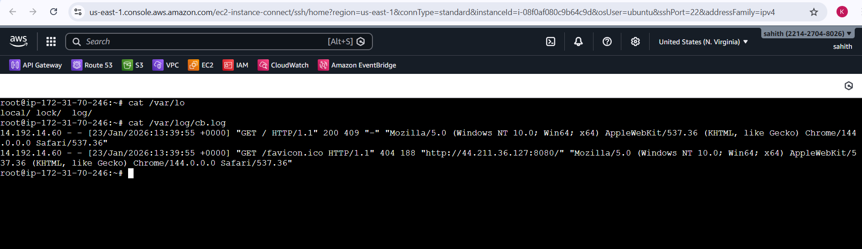

Validation Steps
- EC2 instance running and reachable
- Docker container running on port 8000
- Nginx reverse proxy working on port 8080
- Logs generated in /var/log/cb.log
- Logrotate configuration verified

Issues Faced
- Default Nginx configuration initially conflicted with custom reverse proxy
- Issue resolved by removing the default site and enabling custom configuration
Conclusion
The task was successfully completed using Terraform to provision AWS infrastructure and automate application deployment. Docker was used to run the application, Nginx was configured as a reverse proxy to forward traffic from port 8080 to port 8000, logs were stored in /var/log/cb.log, and log rotation was implemented. The solution follows Infrastructure as Code (IaC) and DevOps best practices.

